LAB 3:

1. Traditional switch vs openflow switch.

Traditional switch operates on proprietary protocols to forward network traffic based on the destination MAC address. an OpenFlow switch is a software-defined network switch that uses the OpenFlow protocol to allow the central controller to determine the flow rules for forwarding network traffic. When the controller is off, then network comes back to traditional switching as a back up.

2.

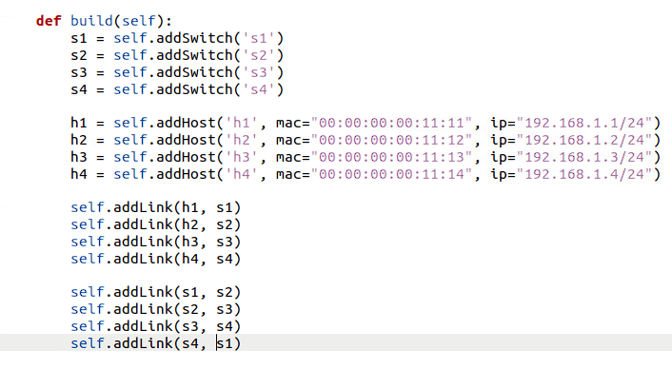

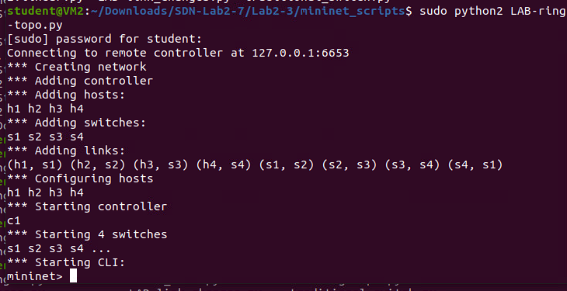

3.

2 lines added to code:

